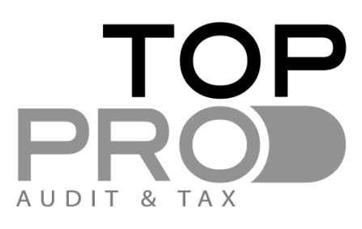
CAPITAL GAINS TAX CYPRUS

CAPITAL GAINS TAX IS APPLICABLE ON

- Sale of immovable property situated in Cyprus belonging to an individual.

- Sale of shares of a Company holding immovable property situated in Cyprus.

- Capital Gains tax is imposed when the disposal is not subject to Income Tax.

CAPITAL GAINS TAX RATE & TAX CALCULATION

- 20% on Net Capital Profit

- Net Capital Profit is the difference between the sale proceed and the cost plus the indexation allowance.(based on the Property value dated 1.1.1980).

- Exemptions are applied (once in a Lifetime for each individual).

- Deductions are also allowed from the Capital profit – expenses which are related to the cost of purchase of the property.(ie transfer fees/direct legal fees etc)

EXEMPTIONS- NON TAXABLE TRANSACTIONS

- Transfer of immovable property between family members.(3rd degree level)

- Transfer to a Limited Company-if the shareholders are the individual owner family members.

- Transfer to Non profit organisations.

- Transfer under Company’s restructuring.

- Exchange of properties- the transaction/profit is not taxable if the profit is used for the purchase of new Immovable property.
- Individuals can deduct from the Capital Gain the amount of Euro 85.430 (disposal of Private residence-lifetime exemption).

**IMPORTANT NOTE- IN ORDER TO CALCULATE THE NET CAPITAL PROFIT AND THE CAPITAL GAINS TAX ARISING SPECIFIC INFORMATION IS REQUIRED** (CASE BY CASE).

