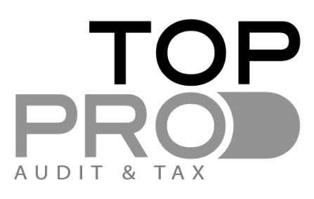

OBLIGATIONS OF A CYPRUS LIMITED COMPANY

Accounts and Audited Financial Statements

- Maintain accounting records / bookkeeping procedure based on Cyprus Companies and Tax Law.
·
- Prepare annual financial statements audited by an independent auditor. This is required by the Tax Laws even if a Company is of small size and it is exempt from audit by the Companies Law.

Group Financial Statements

- Prepare annual consolidated financial statements audited by an independent auditor if the Group is not of “Small size”. This is in harmony with E.U. Directives.

A group of “Small size” is determined by certain characteristics

Corporation Tax -12.5% on the Company’s Taxable Income

- Acquisition of a Tax Identification Code (T.I.C.)

- Submission of annual tax return (IR4) based on the audited financial statements for each year.

- Annual declaration that the Company’s shareholders are non-resident and they are not subject to deemed distribution tax on dividends

- Submission of tax exemption certificate in the case of payment of dividends

- Submission of annual analytical declaration of employees’ deductions
Payment of taxes

- Declaration and payment of provisional tax in 2instalments for the tax year (August & December)

- Payment of final tax of the year by 1 August of the next year without any penalties.

For more details go to Tax calendar

VAT

- VAT registration required by law if the Company:
makes taxable supplies or
provides zero-rated services to other E.U. businesses (also need to
register for VIES)
conducts business in the E.U. and receives services from other E.U. or
non-E.U. businesses

- Voluntary registration is also allowed.

Social Insurance and Payee deductions

- Registration with the Social insurance department as an employer if applicable

- Monthly payment of Social Contributions for Directors and other employees-If the company is registered.

- Monthly payment of PAYE for Directors and other employees-if the company is registered.

Registrar of Companies

- Submission of the company annual return for the year together with the annual audited accounts for the previous year (or the consolidated accounts if applicable).

- Obligation to pay annual levy tax for the amount of Euro 350. (For both active and non active companies).

